**How to send email in Jenkins:**

* Go to manage Jenkins-> configure system -> e-mail notification section

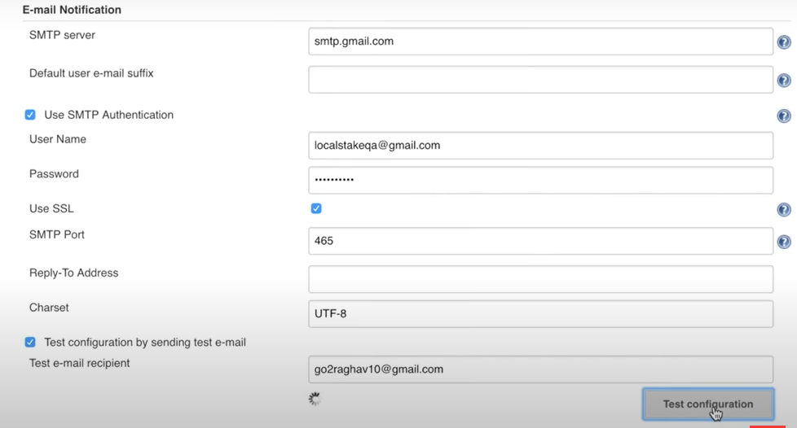

Here in username and password we need to give details of email from where emails will be send. Also give other details and click on Test configuration.

After that you need to configure job and in the post-build action choose email notification and mention about the recipient.

**What is pipeline in Jenkins:**

Pipeline is a workflow with group of events or jobs that are chained and integrated with each other in sequence.

Every job in pipeline has some dependency on one more other jobs. Jobs do some kind of processing/action.

